A WAVELET APPROACH TO EDGE DETECTION

SYNOPSIS

This Project thesis presents a new approach to edge detection using wavelet transforms. First, we briefly introduce the development of wavelet analysis. Then, some major classical edge detectors are reviewed and interpreted with continuous wavelet transforms. The classical edge detectors work fine with high-quality pictures, but often are not good enough for noisy pictures because they cannot distinguish edges of different significance. The proposed wavelet based edge detection algorithm combines the coefficients of wavelet transforms on a series of scales and significantly improves the results. Finally, a cascade algorithm is developed to implement the wavelet based edge detector.
Edge:
An edge in an image is a contour across which the brightness of the image changes abruptly. In image processing, an edge is often interpreted as one class of singularities. In a function, singularities can be characterized easily as discontinuities where the gradient approaches infinity. However, image data is discrete, so edges in an image often are defined as the local maxima of the gradient. This is the definition we will use here. Edge detection is an important task in image processing. It is a main tool in pattern recognition, image segmentation, and scene analysis. An edge detector is basically a high- pass filter that can be applied to extract the edge points in an image. This topic has attracted many researchers and many achievements have been made. In this paper, we will explain the mechanism of edge detectors from the point of view of wavelets and develop a way to construct edge detection filters using wavelet transforms.

edge detection

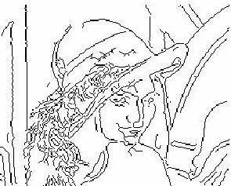
(a) Lena image (b) Edges using Canny detector
Applications:

- Medical imaging
- Locate objects in satellite images (roads, forests, etc.)
- Face Recognition
- Fingerprint Recognition
- Traffic Control Systems
- Break light detection
- Machine vision
- Agricultural imaging-crop disease detection

